

Lab – Troubleshooting EtherChannel

**Topology**

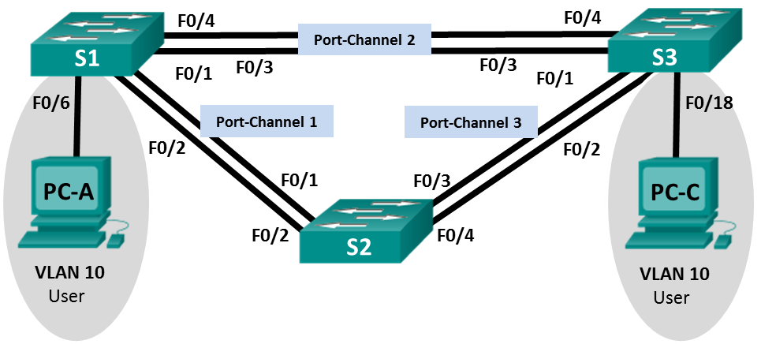

G1/0/6

G1/0/6

S3

S4

G1/0/7

G1/0/5

G1/0/1

G1/0/5

G1/0/3

G1/0/24

G1/0/2

G1/0/4

S1

Ethernet PC

VAN PC

**Addressing Table**

|  |  |  |  |
| --- | --- | --- | --- |
| **Device** | **Interface** | **IP Address** | **Subnet Mask** |
| S1 | VLAN 99 | 192.168.1.11 | 255.255.255.0 |
| S3 | VLAN 99 | 192.168.1.13 | 255.255.255.0 |
| S4 | VLAN 99 | 192.168.1.14 | 255.255.255.0 |
| PC-A | NIC | 192.168.0.2 | 255.255.255.0 |
| PC-C | NIC | 192.168.0.3 | 255.255.255.0 |

**VLAN Assignments**

|  |  |
| --- | --- |
| **VLAN** | **Name** |
| 10 | User |
| 99 | Management |

**Objectives**

**Part 1: Build the Network and Load Device Configurations Part 2: Troubleshoot EtherChannel**

**Background / Scenario**

The switches at your company were configured by an inexperienced network administrator. Several errors in the configuration have resulted in speed and connectivity issues. Your manager has asked you to

troubleshoot and correct the configuration errors and document your work. Using your knowledge of EtherChannel and standard testing methods, find and correct the errors. Ensure that all of the EtherChannels use Port Aggregation Protocol (PAgP), and that all hosts are reachable.

**Note**: Make sure that the switches have been erased and have no startup configurations.

**Required Resources**

* 3 Switches
* 2 Virtual PCs (if on-campus)
* Ethernet cables as shown in the topology

# Part 1: Build the Network and Load Device Configurations

In Part 1, you will set up the network topology, configure basic settings on the PC hosts, and load configurations on the switches.

**Step 1: Erase the startup and VLAN configurations and reload the switches. Step 2: Verify the network is cabled as shown in the topology.**

**Step 3: In on-campus, configure the PC hosts.**

**Step 4: Load switch configurations.**

Load the following configurations into the appropriate switch. As all switches are Cisco devices, the network administrator decided to use Cisco’s PAgP on all port channels configured with EtherChannel. Switch S2 is the root bridge for all VLANs in the topology.

## Switch S3 Configuration:

hostname S3

interface range g1/0/1-24, g1/1/1-4 shutdown

exit

no ip domain lookup line con 0

logging synchronous exit

vlan 10 name User

vlan 99

Name Management interface range g1/0/1-2

switchport mode trunk channel-group 1 mode active

switchport trunk native vlan 99 no shutdown

interface range g1/0/5-6 channel-group 2 mode desirable

switchport trunk native vlan 99 no shutdown

interface g1/0/7 switchport mode access switchport access vlan 10 no shutdown

interface vlan 99

ip address 192.168.1.13 255.255.255.0

interface port-channel 1 switchport trunk native vlan 99 switchport mode trunk

interface port-channel 2 switchport trunk native vlan 99 switchport mode access

## Switch S1 Configuration:

hostname S1

interface range f0/1-24, g0/1-2 shutdown

exit

no ip domain lookup line con 0

logging synchronous exit

vlan 10 name User

vlan 99

name Management

spanning-tree vlan 1,10,99 root primary interface range f0/1-2

switchport mode trunk

channel-group 1 mode desirable switchport trunk native vlan 99 no shutdown

interface range f0/3-4 switchport mode trunk

channel-group 3 mode desirable switchport trunk native vlan 99

interface vlan 99

ip address 192.168.1.11 255.255.255.0

interface port-channel 1 switchport trunk native vlan 99

switchport trunk allowed vlan 1,99 interface port-channel 3

switchport trunk native vlan 99 switchport trunk allowed vlan 1,10,99 switchport mode trunk

## Switch S4 Configuration:

hostname S4

interface range g1/0/1-24, g1/1/1-4 shutdown

exit

no ip domain lookup line con 0

logging synchronous exit

vlan 10 name User

vlan 99

name Management interface range g1/0/3-4 interface range g1/0/5-6

switchport mode trunk

channel-group 3 mode desirable switchport trunk native vlan 99 no shutdown

interface g1/0/24 switchport mode access switchport access vlan 10 no shutdown

interface vlan 99

ip address 192.168.1.14 255.255.255.0

interface port-channel 3 switchport trunk native vlan 99 switchport mode trunk

# Part 2: Troubleshoot EtherChannel

In Part 2, you must examine the configurations on all switches, make corrections if needed, and verify full functionality.

**Step 1: Troubleshoot S3.**

1. Use the **show interfaces trunk** command to verify that the port channels are functioning as trunk ports.



Do port channels 1 and 2 appear as trunked ports?

* Port channels 1 and 2 do not appear as trunked ports

1. Use the **show etherchannel summary** command to verify that interfaces are configured in the correct port channel, the proper protocol is configured, and the interfaces are in use.

Based on the output, are there any EtherChannel issues? If issues are found, record them in the space provided below.

Based on the output, there are errors in the satus of the ports in both Port-Channels (Po1 and Po2).

- Port channel 1 (Po1 – LACP):

+ The Po1 (Port-channel 1) group is in SD state which means that “Layer2 Down)

+ Ports (GigabitEthernet1/0/1 and GigabitEthernet1/0/2) are in “I” state (stand-alone)

- Port channel 2 (Po2 – PAgP):

+ The Po2 (Port-channel 2) group is in the “SD” state, indicating the Layer2 Down

+ Ports (Gi1/0/5 and Gi1/0/6) are also in the “I” state (stand-alone).

Use the command **show run | begin interface Port-channel** command to view the running configuration beginning with the first port channel interface.

1. Resolve all problems found in the outputs from the previous **show** commands. Record the commands used to correct the configurations.

Command lines for Switch S3:

* For port-channel 1 (Po1):

interface gi1/0/5

no shutdown

switchport mode trunk

interface gi1/0/6

no shutdown

switchport mode trunk

interface range gi1/0/5-6

switchport trunk native vlan 99

switchport mode trunk

* For port-channel 2 (Po2):

interface gi1/0/1

no shutdown

switchport mode trunk

interface gi1/0/2

no shutdown

switchport mode trunk

interface range gi1/0/1-2

switchport trunk native vlan 99

switchport mode trunk

1. Use the **show interfaces trunk** command to verify trunk settings.

1. Use the **show etherchannel summary** command to verify that the port channels are up and in use.

**Step 2: Troubleshoot S1.**

1. Issue the command to verify that the port channels are functioning as trunk ports. Record the command used in the space provided below.

* A white paper with black text

  AI-generated content may be incorrect.show interface trunk

1. Based on the output, are there any issues with the configurations? If issues are found, record them in the space provided below.

* Based on the output, there are not any issues with the configurations.

1. Issue the command to verify that interfaces are configured in the correct port channel and the proper protocol is configured.

=> show etherchannel summary

Based on the output, are there any EtherChannel issues? If issues are found, record them in the space provided below.

=> Based on the output, there are not any EtherChannel issues

1. Use the command **show run | begin interface Port-channel** to view the running configuration beginning with the first port-channel interface.
2. Resolve all problems found in the outputs from the previous **show** commands. Record the commands used to correct the configuration.

* There are not any problems found in the outputs from the previous show commands.

1. Issue the command to verify trunk settings.
2. Issue the command to verify that the port channels are functioning. Remember that port channel issues can be caused by either end of the link.

**Step 3: Troubleshoot S4.**

1. Issue the command to verify that the port channels are functioning as trunk ports.

Based on the output, are there any issues with the configurations? If issues are found, record them in the space provided below.

* Yes, the port-channel 1 is not configured as the trunk port

1. Issue the command to verify that the interfaces are configured in the correct port channel and that the proper protocol is configured.

Based on the output, are there any EtherChannel issues? If issues are found, record them in the space provided below.

* Yes, the port-channel 1 is “SD” (Layer2Down) and ports are “I” (stand-alone)

1. Use the command **show run | begin interface Port-channel** command to view the running configuration beginning with the first port channel interface.
2. Resolve all problems found. Record the commands used to correct the configuration.

* For port-channel 1 (Po1):

interface gi1/0/5

no shutdown

switchport mode trunk

interface gi1/0/6

no shutdown

switchport mode trunk

interface range gi1/0/5-6

switchport trunk native vlan 99

switchport mode trunk

1. Issue the command to verify trunk settings. Record the command used in the space provided below.

* Show interface trunk

1. Issue the command to verify that the port channels are functioning. Record the command used in the space provided below.

* show etherchannel summary

**Step 4: Verify EtherChannel and Connectivity.**

1. Use the **show interfaces etherchannel** command to verify full functionality of the port channels.
2. Verify connectivity of the management VLAN. Can S1 ping S2? => Yes

Can S1 ping S3? => Yes

Can S2 ping S3? => Yes

**Note:** If EtherChannels are not fully functional, connectivity between switches does not exist. Troubleshoot to resolve any remaining issues.

Would PC-A be able to ping PC-C? => Yes

